Order Of Service

Singing: Psalm 89—CW page 98

Reading: Psalm 119:9-16

Opening Hymn: TLH 4

Reading: Romans 2:1-16

Request Hymn: CW Supplement 754

Reading: Matthew 14:1-12

Sermon Hymn: TLH 153

Sermon Text: Mark 14:26-31

The Cock Crow Twice

Prayer

The Apostles’ Creed, TLH page 12

Holy Communion

The Lord's Prayer

The Blessing

Closing Hymn: TLH 52

* * * * * * * * * * *
Bible Study: Lambs: Bittern
Sheep: Proverbs 24:1-5


Spring In Duluth, MN

Water
Of
Life

24 May 2020

W A T E R O F L I F E

Independent Christian Church—Conservative Lutheran Doctrine

Worship Service: 9:30 a.m. Bible Study: 10:45 a.m.

Larry Cooper, Pastor E-Mail address:
111 N. Ridge Road lcooper@wateroflife.cc
Coon Valley, WI 54623 Web Site:
www.wateroflife.cc

* * * * * * * * * * * * * * * * * * * * * * * * * * *

Sermon Text: Mark 14:26-31

The Cock Crow Twice

* * * * * * * * * * * * * * * * * * * * * * * * * * *

Mark 14:26 And when they had sung an hymn, they went out into the mount of Olives.
:27 And Jesus saith unto them, All ye shall be offended because of me this night: for it is written, I will smite the shepherd, and the sheep shall be scattered.
:28 But after that I am risen, I will go before you into Galilee.
:29 But Peter said unto him, Although all shall be offended, yet will not I.
:30 And Jesus saith unto him, Verily I say unto thee, That this day, even in this night, before the cock crow twice, thou shalt deny me thrice.
:31 But he spake the more vehemently, If I should die with thee, I will not deny thee in any wise. Likewise also said they all.

* * * * * * * * * *

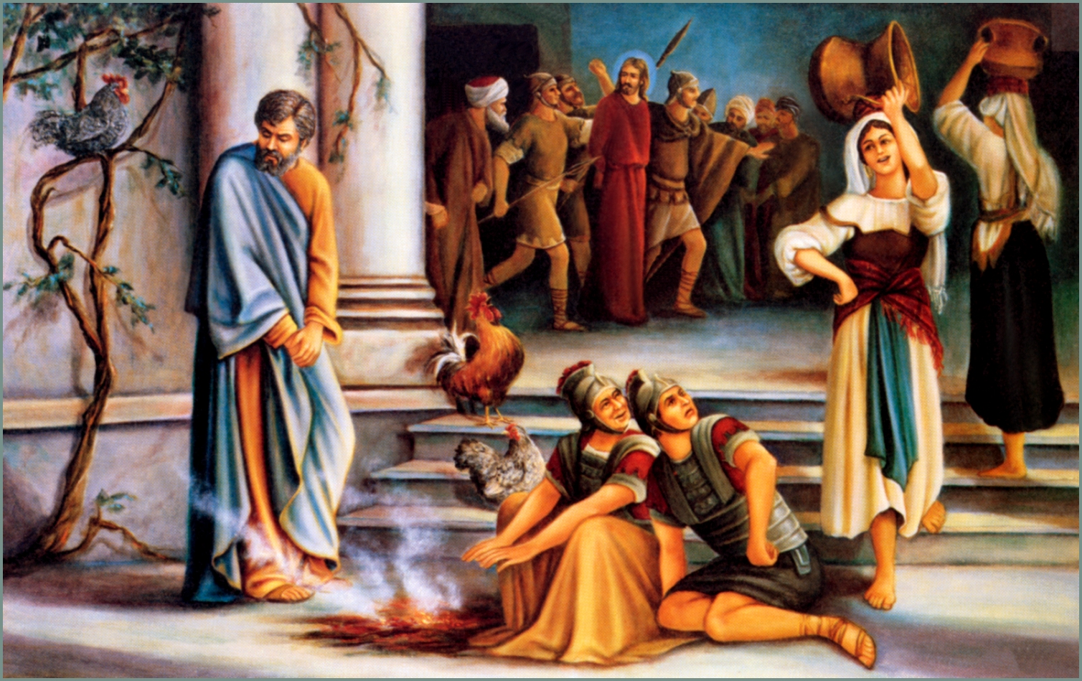

Luke 22:54 Then took they him, and led him, and brought him into the high priest's house. And Peter followed afar off.
:55 And when they had kindled a fire in the midst of the hall, and were set down together, Peter sat down among them.
:56 But a certain maid beheld him as he sat by the fire, and earnestly looked upon him, and said, This man was also with him.
:57 And he denied him, saying, Woman, I know him not.
:58 And after a little while another saw him, and said, Thou art also of them. And Peter said, Man, I am not.
:59 And about the space of one hour after another confidently affirmed, saying, Of a truth this fellow also was with him: for he is a Galilaean.
:60 And Peter said, Man, I know not what thou sayest. And immediately, while he yet spake, the cock crew.
:61 And the Lord turned, and looked upon Peter. And Peter remembered the word of the Lord, how he had said unto him, Before the cock crow, thou shalt deny me thrice.
:62 And Peter went out, and wept bitterly.

